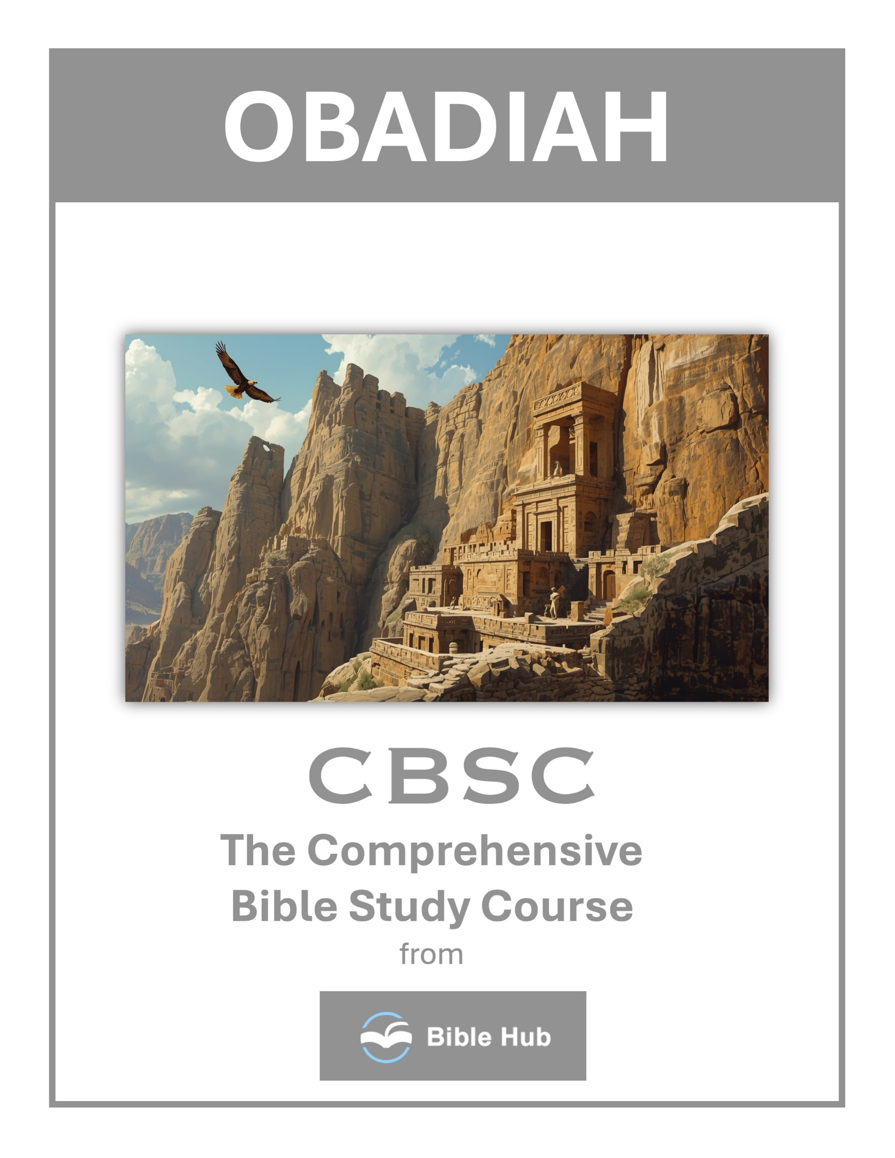

Obadiah 1 Teaching Points and Bible Study Questions
The Sovereignty of God
In the book of Obadiah, we are reminded of God's ultimate control over the nations. Despite the chaos and conflicts that may arise, God is always in charge. Obadiah 1:4 states, "Though you soar like the eagle and make your nest among the stars, even from there I will bring you down, declares the LORD." This verse reassures us that no matter how powerful or untouchable a nation or individual may seem, God's authority is supreme. Trust in His plan and rest in the knowledge that He is the ultimate ruler.
1. How can recognizing God's sovereignty in Obadiah 1 influence your response to life's challenges today?
2. Why do you think acknowledging God's control can impact your daily decision-making and priorities?
3. What practical steps can you take to trust God's sovereignty in uncertain situations?
The Consequences of Pride
Pride is a recurring theme in Obadiah, and it serves as a warning to us all. The Edomites' arrogance led to their downfall, as Obadiah 1:3 warns, "The pride of your heart has deceived you, O dwellers in the clefts of the rocks." Pride blinds us to our vulnerabilities and distances us from God. Let us remain humble, recognizing that all we have is by His grace.
1. How can recognizing pride in your life help you avoid its negative consequences?
2. Why do you think pride often leads to downfall in personal relationships?
3. What steps can you take to cultivate humility in daily interactions?

The Importance of Brotherhood
Obadiah highlights the strained relationship between Edom and Israel, descendants of Esau and Jacob. This serves as a reminder of the importance of maintaining harmony and love among brethren. As believers, we are called to "love one another deeply, from a pure heart" (1 Peter 1:22). Let us strive to mend broken relationships and foster unity within our communities.
1. How can we foster stronger relationships with our siblings or close friends in times of conflict?
2. Why do you think maintaining unity with others is crucial in challenging situations?
3. What practical steps can you take to support a friend or family member in need?
Justice Will Prevail
The book of Obadiah assures us that God's justice will ultimately prevail. The Edomites' actions against Israel did not go unnoticed, and God promised to hold them accountable. Obadiah 1:15 declares, "As you have done, it will be done to you; your recompense will return upon your own head." This is a powerful reminder that God sees all and will bring justice in His perfect timing.
1. How can you actively contribute to justice in your community, reflecting Obadiah's message?
2. Why do you think justice is essential for maintaining peace and harmony in society?
3. What can you learn from Obadiah about trusting in divine justice during personal conflicts?

The Day of the Lord
Obadiah speaks of the "day of the LORD," a time of judgment and restoration. This concept is a call to readiness and reflection. Obadiah 1:15 states, "For the Day of the LORD is near for all nations." As we await this day, let us live righteously, sharing the hope of salvation through Jesus Christ with those around us.
1. How can you prepare for the Day of the Lord in your daily life?
2. Why do you think the Day of the Lord is significant for personal reflection and growth?
3. What actions can you take to align with God's justice before the Day of the Lord?
The Power of Repentance
While Obadiah primarily addresses judgment, it also implicitly calls for repentance. The Edomites' fate could have been different had they turned from their ways. In our lives, repentance is a powerful tool for transformation. As 1 John 1:9 assures us, "If we confess our sins, He is faithful and just to forgive us our sins and to cleanse us from all unrighteousness."
1. How can recognizing our mistakes lead to genuine repentance and transformation in our daily lives?
2. Why do you think repentance is essential for healing broken relationships and fostering community?
3. What practical steps can you take to embrace repentance and seek reconciliation with others?

God's Faithfulness to His People
Despite the trials faced by Israel, God remained faithful to His covenant people. Obadiah 1:17 promises, "But on Mount Zion there will be deliverance, and it will be holy." This is a testament to God's unwavering commitment to His promises. We can take comfort in knowing that God is faithful and will never abandon His children.
1. How can you trust in God's faithfulness when facing personal challenges or injustices today?
2. What do you hope to learn about God's faithfulness through the story of Edom's downfall?
3. Why does recognizing God's faithfulness encourage you to remain steadfast in your own commitments?
The Futility of Trusting in Worldly Strength
Edom's reliance on their strategic location and alliances proved futile. Obadiah 1:7 reveals, "All the men allied with you will drive you to the border." This serves as a reminder that worldly strength and alliances are temporary. Our true security lies in God alone, who is our refuge and strength.
1. How can you identify and avoid relying on worldly strength in your daily decisions?
2. Why do you think people often trust in material power despite its limitations?
3. What can you do to cultivate trust in spiritual strength over worldly power?

The Call to Stand Against Injustice
Obadiah condemns Edom for standing by while Israel suffered. This challenges us to actively oppose injustice and support those in need. Proverbs 31:8-9 encourages us to "Speak up for those who cannot speak for themselves." Let us be voices for the voiceless and champions of righteousness.
1. How can you actively stand against injustice in your community today, inspired by Obadiah 1?
2. Why do you think it's important to confront injustice, as seen in Obadiah 1?
3. What practical steps can you take to support those facing injustice, reflecting on Obadiah 1?
Hope for Restoration
The book of Obadiah concludes with a message of hope and restoration for Israel. Obadiah 1:21 proclaims, "Deliverers will ascend Mount Zion to judge the mountains of Esau, and the kingdom will belong to the LORD." This is a beautiful reminder that God is in the business of restoration. No matter how broken our circumstances may seem, God can and will restore us in His time. Let us hold onto this hope and share it with others.
1. How can you find hope for restoration in challenging situations, as seen in Obadiah 1?
2. What do you hope to learn from God's promise of restoration in your personal life?
3. Why do you think restoration is important for healing and growth in your community?

